PROGRAM

#include<stdio.h>

struct poly{

int coeff;

int exp;

}a[10],b[10],c[10],d[10];

int read(struct poly r[10])

{

int l,i;

printf("\nEnter the total number of terms:");

scanf("%d",&l);

for(i=0;i<l;i++){

printf("\nterm %d",i+1);

printf("\nCoefficent:");

scanf("%d",&r[i].coeff);

printf("Exponent:");

scanf("%d",&r[i].exp);

}

return l;

}

int show(struct poly r[10],int len)

{

int i;

printf("\n");

for(i=0;i<len;i++)

printf("%dX^%d+",r[i].coeff,r[i].exp);

printf("0");

}

int addition(struct poly a1[10],int la,struct poly b1[10],int lb)

{

int i=0,j=0,k=0;

while(i<la && j<lb)

{

if(a1[i].exp==b1[j].exp)

{

c[k].coeff=a1[i].coeff+b1[j].coeff;

c[k].exp=a1[i].exp;

i++;

j++;

k++;

}

else if(a1[i].exp>b1[j].exp)

{

c[k].coeff=a1[i].coeff;

c[k].exp=a1[i].exp;

i++;

k++;

}

else if(a1[i].exp<b1[j].exp)

{

c[k].coeff=b1[j].coeff;

c[k].exp=b1[j].exp;

j++;

k++;

}

}

while(i<la)

{

c[k].coeff=a[i].coeff;

c[k].exp=a[i].exp;

i++;

k++;

}

while (j<lb)

{

c[k].coeff=b1[i].coeff;

c[k].exp=b1[i].exp;

j++;

k++;

}

return k;

}

int multiplication(struct poly a1[10],int la,struct poly b1[10],int lb)

{

int q=0,i,j,k,flag;

for(i=0;i<la;i++)

for(j=0;j<lb;j++)

{

flag=0;

for(k=0;k<=q;k++)

{

if((a1[i].exp+b1[j].exp)==d[k].exp)

{

d[k].coeff+=(a1[i].coeff\*b1[j].coeff);

flag=1;

}

}

if(flag==0)

{

d[q].coeff=a1[i].coeff\*b1[j].coeff;

d[q].exp=a1[i].exp+b1[j].exp;

q++;

}

}

return q+1;

}

void main()

{

int response;

int lc,ld,la,lb,i;

char repeat='y';

while(repeat=='y')

{

printf("<<<First Polynomial>>>");

la=read(a);

printf("\nThe Entered Polynomial is:");

show(a,la);

printf("\n\n<<<Second Polynomial>>>");

lb=read(b);

printf("\nThe Entered Polynomial is:");

show(b,lb);

printf("\n\n\n\*\*\*\*\*SELECT THE OPERATION\*\*\*\*\*\n1. Polynomial addition\n2.Polynomial Multiplication\n");

scanf("%d",&response);

if(response==1)

{

lc=addition(a,la,b,lb);

printf("\nThe Sum is:\n");

show(c,lc);

}

else if(response==2)

{

ld=multiplication(a,la,b,lb);

printf("\nThe product is:\n");

show(d,ld);

}

else

{

printf("Wrong Input");

}

printf("\n\nDo you Want to Continue?(y/n)");

scanf("%s",&repeat);

}

}

OUTPUT

TEST CASE 1:

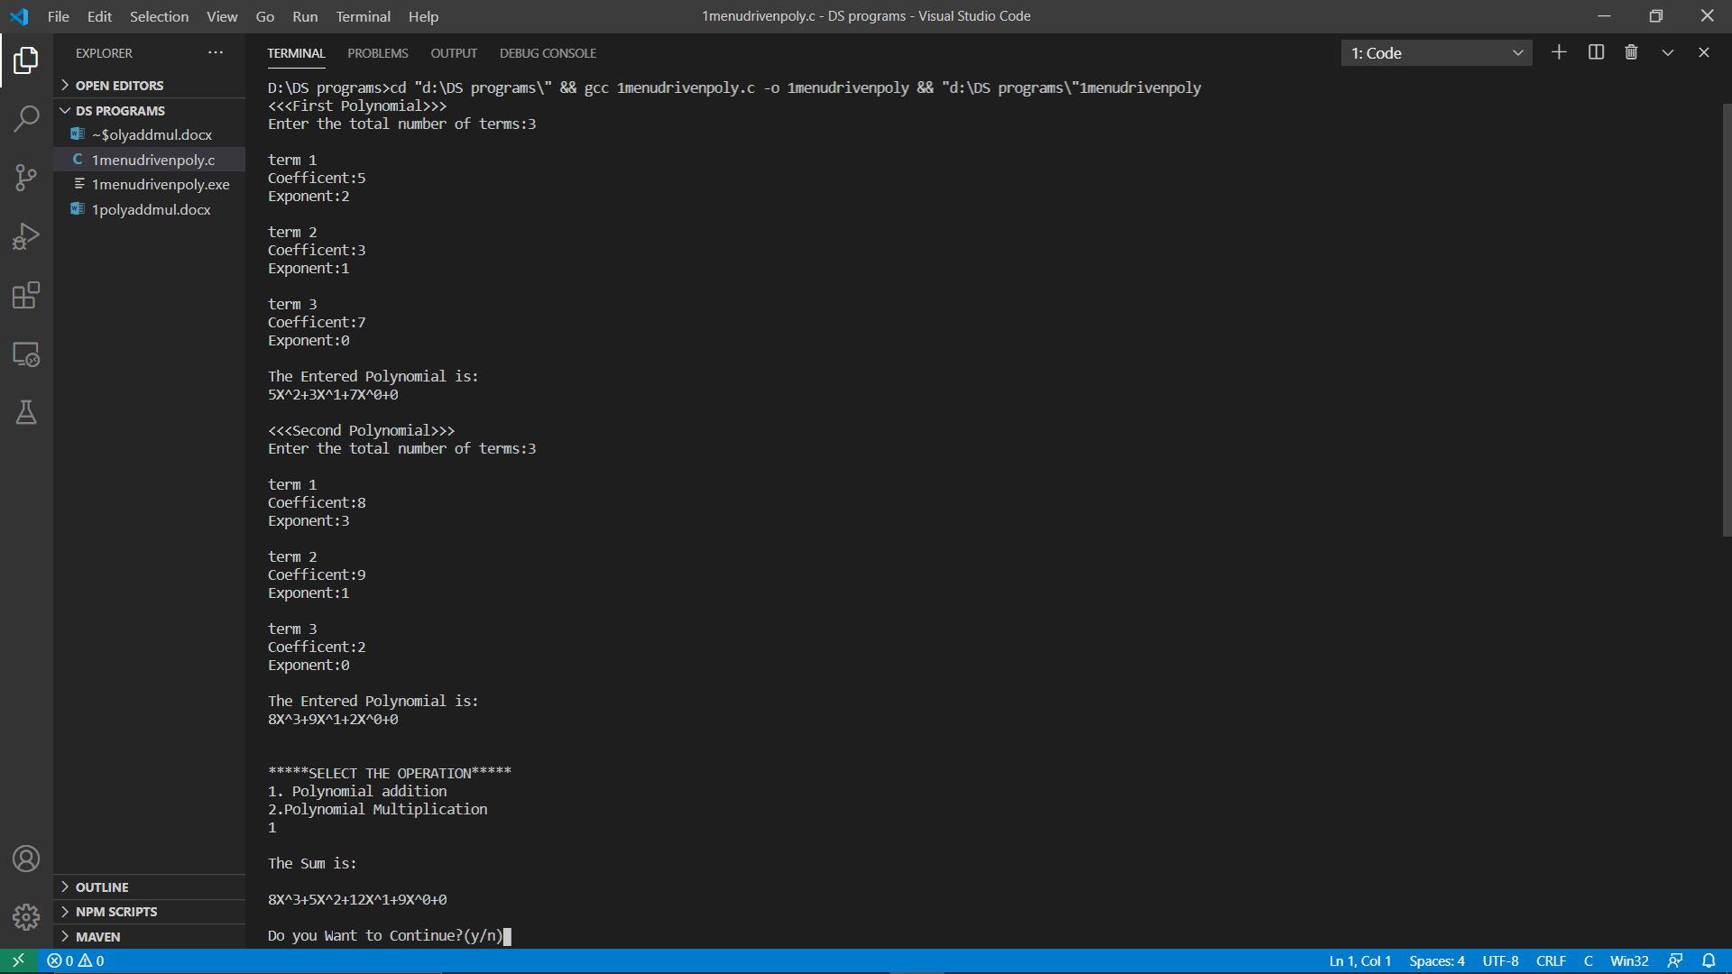

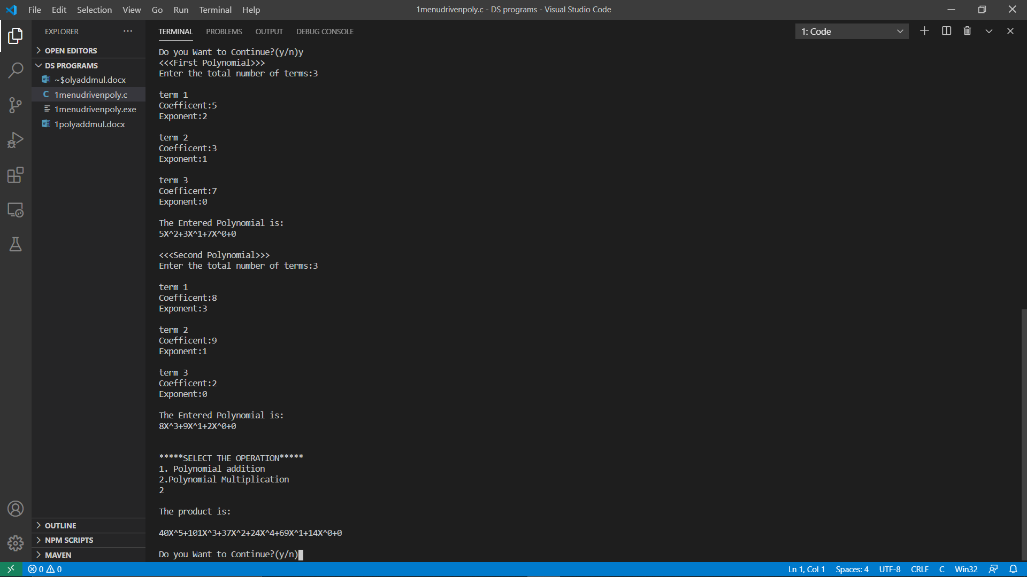

TEST CASE 2:

